St Joseph’s College
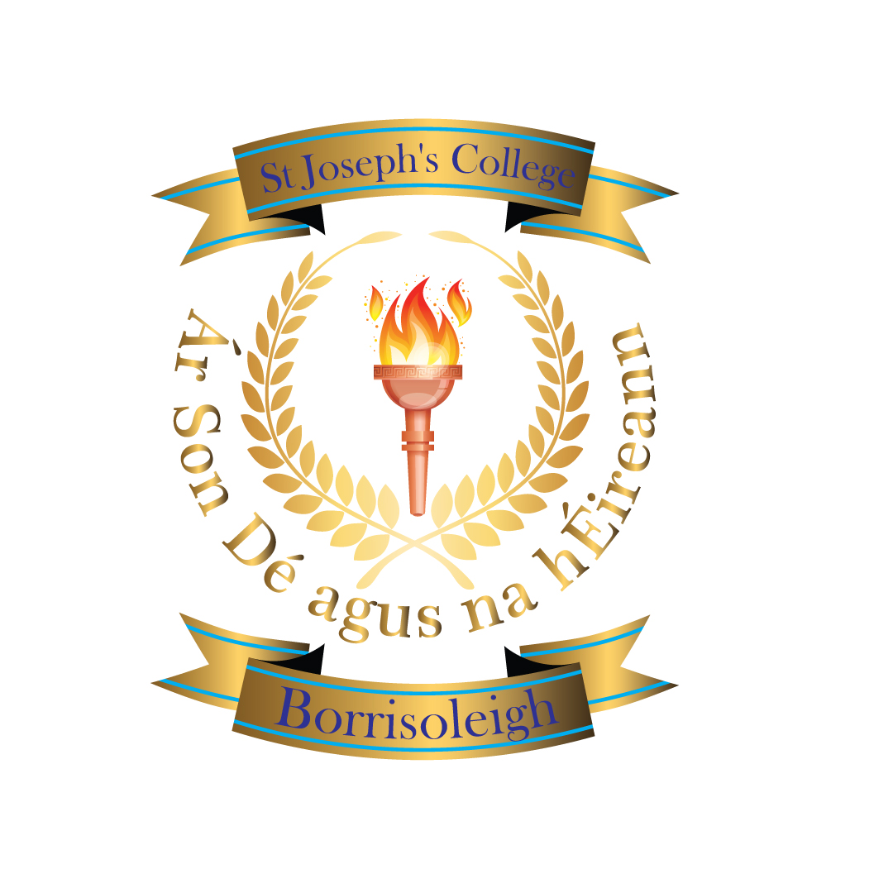

Borrisoleigh

thurles

Co. Tipperary

Phone/Fax:(0504)51215/(0504)51701

email:office@stjosephscollege.ie

www.stjosephscollege.ie
ENROLMENT FORM 2020/2021
Please fill in all section below
Section A: Personal Information
Section B: Educational Requirements
Section C: Medical Information
Section D: Image Consent

Tick as appropriate
Mainstream
Special Class

Section A: PERSONAL INFORMATION

Pupil’s Surname:_______________________ Forename:____________________________
(as on his/her Birth Cert)
Name by which child is known: _________________________________________________

Date of Birth:___________________________ PPS No.__________________________________

School currently attending:__________________________________________________________

Home Address:____________________________________________________________________
_________________________________________________________________________________
Home Phone No:___________________________ Contact Mobile:__________________________

Country of Birth:_______________________ Passport(s) held:____________________________
(e.g. Irish)
Father’s Full Name:__________________________________Mobile No.:_____________________

Email address: __________________________

Mother’s Full Name:________________________________Maiden Name:____________________

Mobile No:_________________________________ Email address: __________________________

Name/s and Address/es for Correspondence:____________________________________________
__________________________________________________________________________________
No. of Children in Family:________ Boys _____ Girls _____ Place in Family:_______

Siblings who are presently attending this school
Name:____________________________________ Year Group_________________________
Name:____________________________________ Year Group_________________________
Section B: EDUCATIONAL REQUIREMENTS

Does your child receive any additional learning support? Yes/No
Does your child receive Resource hours? Yes/No
Does your child receive Special Needs Assistance hours? Yes/No
If yes, give details… ____________________________________________________________________________________________________________________________________________________________________________________

Are you exempt from Irish? Yes/No
If yes, please supply certificate of exemption with this enrolment form. All students must study Irish unless they have a certificate as per Dept. of Education & Skills regulations.

Does your child have an assessment: psychological/occupational/speech/other? Yes/No

Please provide a copy of these reports when returning this application.

If you answer yes to any of the above questions our Special Education Needs co-ordinator will be in contact by phone to discuss your child’s educational planning further.

Standardised testing may be carried out for the purpose of literacy & numeracy progress, assisting in referral to outside agencies such as NEPs, for career guidance information and for reasonable accommodation in the State examinations.

I give permission for the school to carry out such tests.

________________________ ________________
PARENT/GUARDIAN DATE

Section C: MEDICAL INFORMATION
In the event of an accident or medical emergency, we ask your permission to bring your child to the doctor/ hospital.
Signed:___________________________________________

Family Doctor’s Name:_________________________________ Phone No.____________________

Does your child suffer from allergies? (Give details – e.g. penicillin, nuts, etc)
___________________________________________________________________________________

Has your child any health issues that would affect full participation in school life? (Give details)
___________________________________________________________________________________
___________________________________________________________________________________

Eyesight problems?___________________________________________________________

Hearing problems?___________________________________________________________

Section D: Image Use
Parents / Guardians are advised that by signing this form they are indicating their consent to this information being held by the school and to it being shared with the Department of Education and Skills and that your child’s image may be used for promotional/ inhouse purposes.

Signed:___________________________________________ (Parent/Guardian)

Signed:___________________________________________ (Parent/Guardian)

