St Joseph’s College
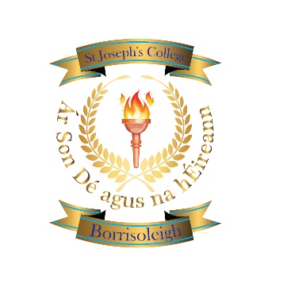

Borrisoleigh

thurles

Co. Tipperary

Phone:(0504)51215

email:office@stjosephscollege.ie www.stjosephscollege.ie

2nd Year Sept 2026
All students study the following subjects:

Irish
English
Maths
French
Science
Business Studies
Geography
History
Religion
Module - Coding
Option Bands
Pick 1 from each band
Band 1 - Materials Technology
Band 1 - Music
Band 1 - Applied Technology
Band 2 - Applied Technology
Band 2 - Graphics
Band 2 - Home Economics
Band 2 - Visual Art
Wellbeing
CSPE
SPHE
PE
Learning to Learn

