St Joseph’s College
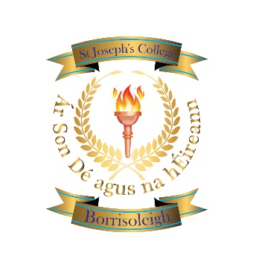

Borrisoleigh

thurles

Co. Tipperary

Phone:(0504)51215

email:office@stjosephscollege.ie www.stjosephscollege.ie

3rd Year Sept 2026
All students study the following:
Subjects
Irish
English
Maths
French
Science
Business Studies
Geography
History
Religion
Module - Coding
Option Bands
Pick 1 from each band
Band 1– Home Economics
Band 1 – Materials Technology
Band 1 – Music
Band 1 – Applied Technology
Band 2 – Applied Technology
Band 2 – Materials Technology
Band 2 – Graphics
Band 2 – Visual Art
Wellbeing
CSPE
SPHE
PE
Learning to Learn

