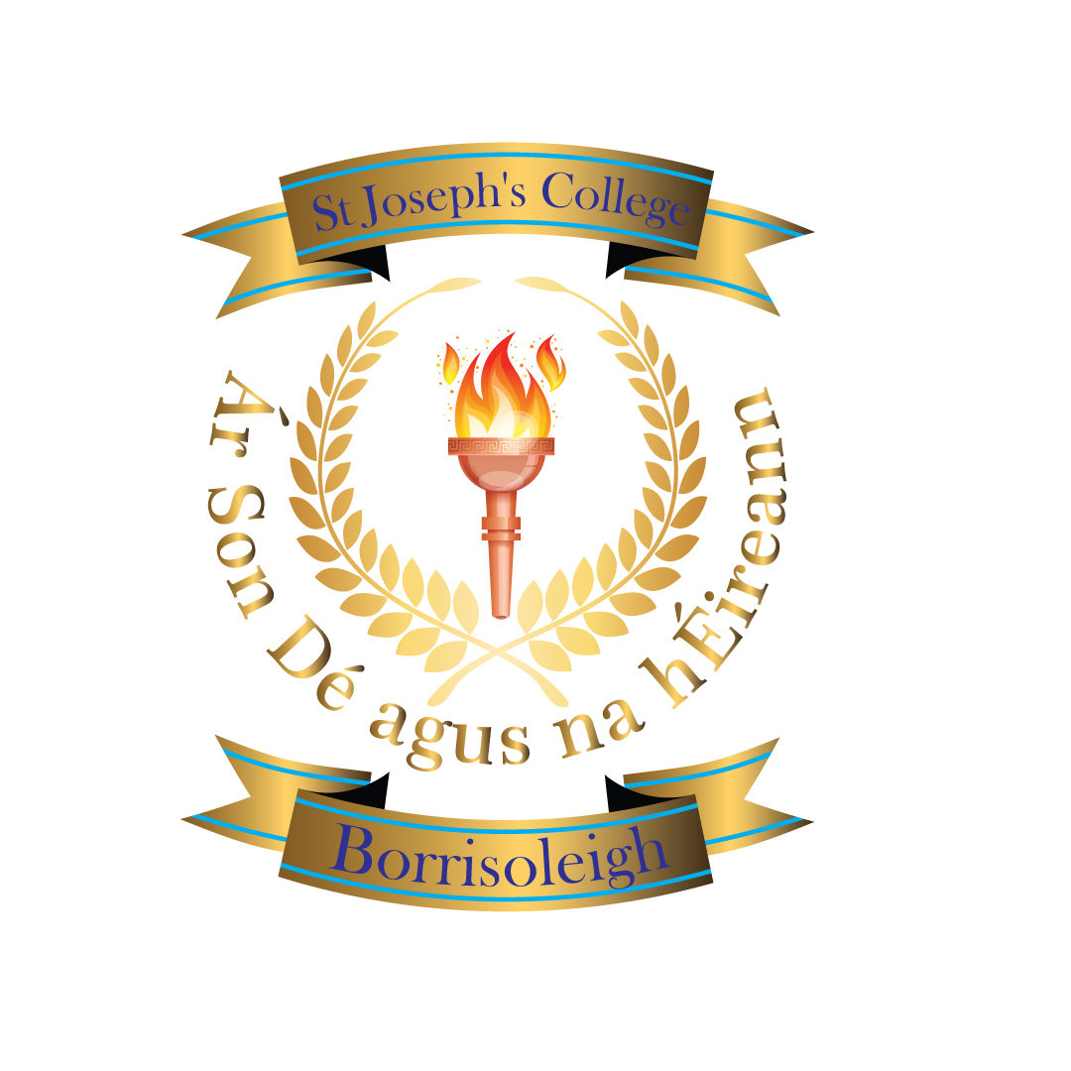
Transition Year 2026–2027
St. Joseph’s College, Borrisoleigh
Welcome
Transition Year (TY) is a unique opportunity for students to grow in confidence, independence, and maturity while exploring learning beyond the classroom. It allows students to develop key life skills before beginning their Senior Cycle.

What is Transition Year?
Transition Year is a one-year programme between Junior Cycle and Senior Cycle. It focuses on personal development, learning through experience, and preparing students for future pathways in education, training, and employment.
- Department of Education Vision for TY:
- Nurture the development of the student as a whole person.
- Provide meaningful, enjoyable learning experiences.
- Expand awareness of future pathways and lifelong learning.
- Continuously evolve through reflection and feedback.

The Four Dimensions of TY

- Personal Growth:  Confidence  Independence  Responsibility  Wellbeing  Leadership | - Being a Learner  Projects  Teamwork  Presentations  Problem - solving
- Civic & Community Engagement:  Volunteering  Charity work  Community links | - Career Readiness  Work Experience  Career exploration  CV and interviews

What Will Students Do in TY?
- Work experience placements
- Short courses and modules
- Guest speakers and workshops
- Trips and educational visits
- Community and charity projects
- Enterprise and teamwork projects
- Personal development programmes

Is TY Right for My Child?
- TY suits students who:
- Want to mature before Senior Cycle
- Are willing to try new things
- Want to build confidence
- Are open to learning in different ways
- TY may be challenging for students who:
- Need very strong structure all the time and definite schedules
- Are not willing to actively engage in opportunities offered to them

Application Process

- Applying for TY 2026–2027
Application Form: TY Application Form 2026-2027 – Fill out form
– Fill out form or scan QR code:
Closing Date: Friday, 27th February 2026
Students complete the form themselves.

Costs:
The TY programme costs for the year and is inclusive of trips, buses to TY specific trips, workshops, speakers, programmes and entry fees to subject-related programmes. Books and materials.
Not included:
Entry fee to Gaisce and cost of overnight stay and activity
Bus to sporting events/ matches, overnight stay at the Young Scientists
Optional Foreign Trip

Contact Information
If you have any questions, please contact: Mary Gorey
Email: mgorey@stjosephscollege.ie

